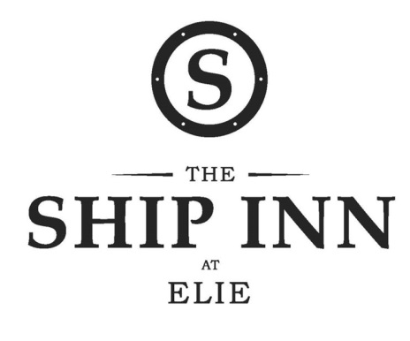

Hogmanay Menu

Nibbles
~o0o~
Lobster & Scallop raviolo, baby spinach, bisque, tomato water
~o0o~
Cream of green asparagus with truffle
~o0o~
Line caught turbot, clam chowder, sweetcorn & spring onion fritter
~o0o~
Venison wellington, celeriac fondant, pearl barley, onion purée, crispy kale, cassis jus
~o0o~
Bombe Alaska
~o0o~
Tea/Coffee & petit fours

£65 per person

