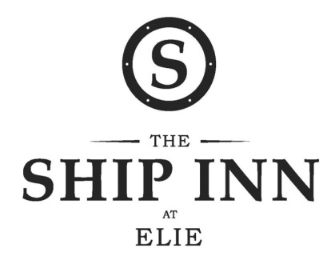
Christmas Set Menu

Hot & cold smoked salmon, pickled vegetables, fine herbs, horseradish crème fraiche
Duck liver parfait, duck rillettes, pear chutney, soda bread, quince aioli
Cullen skink
-----------------------
Traditional roast turkey with all the trimmings
Crispy skin seabass, Scottish seafood stew, fennel, saffron aioli
Jerusalem artichoke and broad bean risotto, cultivated mushrooms, baby spinach, green asparagus
-----------------------
Christmas pudding, brandy butter, vanilla custard
Glazed lemon tart, raspberry sorbet
Cappuccino iced parfait, cinnamon doughnuts
-----------------------
Mince pies & coffee
-----------------------
2 courses - £18.50
3 courses - £22.50

